Installing Apache2
For enabling Apache2 there are a few steps needed:
- First, update all packages with the following command:
- Use the following command to install Apache2:

Installing PHP & MySQL
The following steps are required for installing php:
- The first step required to install php
- To run scripts in the terminal prompt, use this command:
- To run php script without the apache module:
- To use MySQL run the following command:
- Next configure with the following command:

Installing SFTP
First thing to do is install SSH if not done yet:
- Once SSH is installed, we need to make some changes to the SSHD configuration file:
- Add the next lines to your code at the bottom:
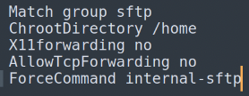
- Restart the SSH service for changes to take effect:

Next up we create an SFTP user account.
- Create a new user group called sftp:
- Next, create a new user:
- Setup a new password:
- Grant full access to user on their home directory:

Next we log in with the hostname or IP address of your system:
- Login with this command:
- Navigate to home directory, in here make a directory ex. sftp-test, go to that directory:
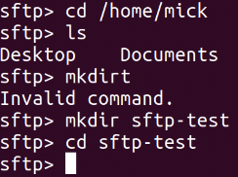

Next up we want to log in to SFTP using GUI:
- Open the nautilus file manager on Ubuntu, go to other locations.
- Fill in the user and server and click connect:
- Enter credentials.
- Open your home directory and you should see the sftp-test folder.
Successfully connected to the server.

Installing phpMyAdmin
The following steps are required to install and secure phpMyAdmin.
- First, update all packages with the following command:
- Run the following command to install these packages, make sure to first hit SPACE and TAB and then ENTER to get it working correctly:
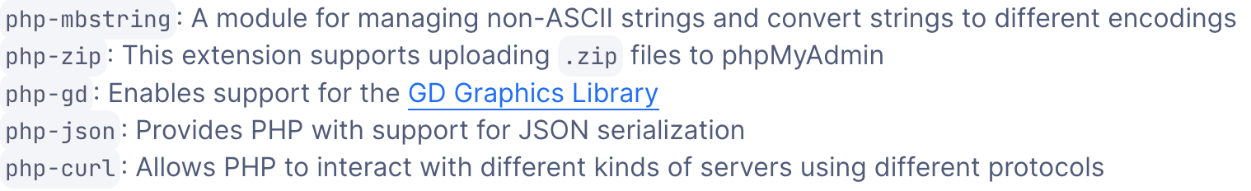
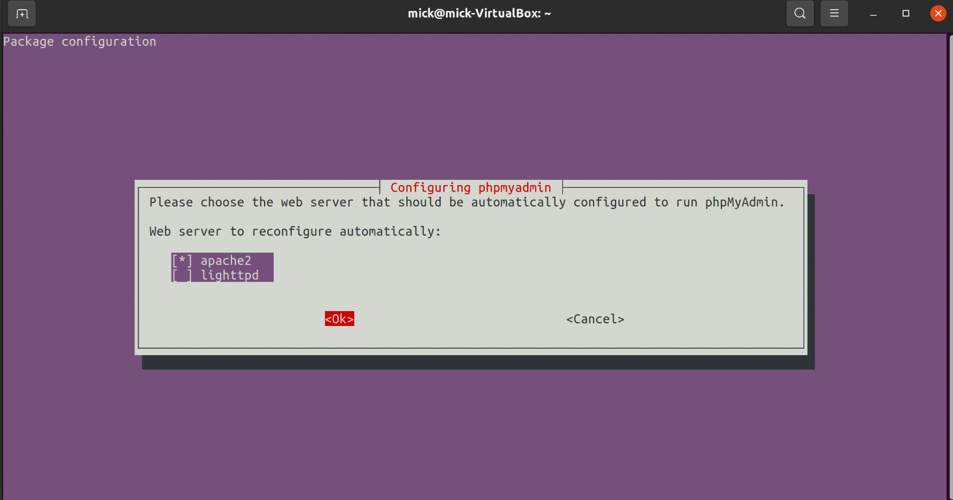
HIT SPACE TAB AND ENTER HERE!!!!!

- Select Apache2.
- Select yes for configuring a database.
- Make a password

If an error occurs select abort, this will be solved.
- Open MySQL: or if you used root password: “$ sudo -u root -p”
- Run the following command:
- Exit the MySQL prompt:
- Install phpMyAdmin and it will work as expected:
- Open MySQL: or if you used root password: “$ sudo -u root -p”
- Reinstall the validate password:
- Exit SQL. (exit;)
To finish configuring Apache2 and php to work with phpMyAdmin follow these steps.
- Enable mbstring extension:
- Restart Apache2 for changes to be recognized:

To login as your root user on phpMyAdmin a few steps are required:
- Open MySQL:
- Run the following command, make sure to have a strong password:
- Run this command, make sure to change ‘password’ into a strong password:
- Then, check the authentication method on root using the same command as before:

Now we need to configure password access for a dedicated MySQL user.
- Open MySQL: or if you used root password: “$ sudo -u root -p”
- Create a user with the following command, make sure to use your own name etc.:
- Now grant all privileges with the following command:
- Exit MySQL;
- Access using the following link: https://’your_domain_or_IP’/phpmyadmin

Installing SNMP

For enabling SNMP (Simple Network Management Protocol) on a Linux system the following steps are required:

- First, update all packages with the following command:
- Now install the SNMP:
- Edit snmpd.conf with text editor of choice (in this case sublime text).
- Next up: configure agent address after opening the conf file. . This will set the server to listen on all IPv4 and IPv6 addresses, (In case there is a # in front of your line, remove it to enable it).
- Now restart the SNMPD service:
- Now check the status using the following command:
The SNMPD is active.
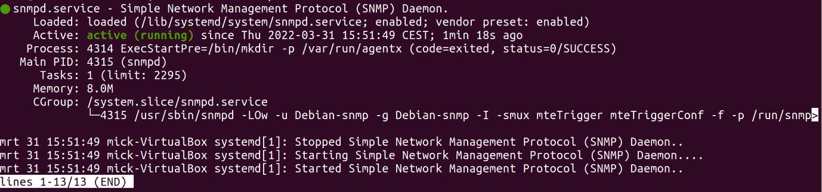

Now the SNMPD is active, setting up the MRTG is necessary to monitor.

Installing MRTG
- Visit the following site and download and extract the following .zip: mrtg-2.17.4.zip
- Install GCC with the following command:
- Check your version of Perl: (should be at least v5.005)
- Download gd, this is a basic graph drawing library: https://github.com/libgd/libgd/releases/tag/gd-2.3.3
- Download libpng, it is required by gd to produce PNG graphics files: http://www.libpng.org/pub/png/libpng.html
- Download zlib, it is needed to compress the graphics files you create: http://www.zlib.net/

Now we need to set up the MRTG:

To get zlib:
If permission is denied, try sudo.
- after that

To get libpng:
Make sure to use capital O: “-O3 -fPIC”
To compile gd:
- (Or the version you’re using)
- Go to root using “sudo -s”

